Cxl: A CxxTest & Linter for Web-CAT

Thomas Graham

CSC 212-T1

[tgraham3@qmail.qcc.edu](mailto:tgraham3@qmail.qcc.edu)

August 13, 2018

**ABSTRACT**

Cxl, or CxxLint is a Web-CAT plugin designed to ingrate C++ code style checking with CxxTest unit testing. The plugin uses Google’s cpplint to perform the style check, and the previous CxxTest unit test, then ties all these elements together and creates output for the user. The paper outlines the different software currently used to grade and the current problems, the methods that were taken to solve these problems, and the various programming and systems used along the way.

**INTRODUCTION**

The main software used in this project was Web-CAT, CxxTest, and cpplint. These were used in conjunction to solve the problem.

Web-CAT is an automated grading software used for checking the student’s code against their own self written tests. This is a web application that is run on a server where the students connect and submit their assignments.

CxxTest is the C++ unit testing framework used by Web-CAT. This supports unit testing, very similarly to Junit for Java.

Web-CAT grades C++ code by using the CppTddPlugin. This plugin comes by default with Web-CAT and will run the provided code and tests, against instructor specified test cases. The plugin will check if the program works by verifying that it passes the test cases.

**METHODS**

The first step was to duplicate the server setup currently being used. The current setup was

using the LAMP archetype. LAMP stands for Linux, Apache, MySQL, and PHP. The entire model

is composed of open-source software, the rival being called WAMP, uses Windows. The PHP

element can also be Perl or Python.

First, to begin the setup of the stack, Ubuntu Server was installed, using the default options, on

to a backup laptop. Next, Apache2 was installed on the Linux machine, and then the web-server

was configured by installing Tomcat7. The version must by Tomcat7. The next step was to setup

MySQL create and manage the different databases. The version of MySQL must be MySQL 5.6

in order to work properly. Finally, Perl and Python were configured on the machine.

Upon testing the server and succeeding, the next step was to setup the Linux environment for use with development. While Ubuntu comes bundled with a lot of software needed, there is still more to install and configure. The next step was to reconfigure Java. The correct version is Java 1.8, setup as default and from Oracle. (Not openJDK). Then, then next step was to install the correct compliers that work with Web-CAT. The correct version gcc-6, and additionally g++-6.

Additionally, multiple packages from Perl had to be installed using cpan.

*NOTE: If a different version is used for any of the software mentioned it will not work properly.*

Finally, after the initial setup was complete, it was time to begin the programming. The next step was to study the current plugin to figure out how it works. The plugin consists of a directory of multiple folders and files in many different programming languages.

The next step was to learn how to write Perl scripts. Perl allows the use of regular expressions which makes searching through code much easier, by allowing highly customizable searches.

Then it was required to learn how Adobe Ant works. This was done by studying the build.xml file in the plugin and updating it throughout the project.

Next, after being able to build the project with small updates being tested, the next step was to learn how the Google Python script was working. The script is what checks the students’ submissions against a Google C++ style standard. This checks for style related issues pertaining to spacing, naming, format, readability, braces, copyright, guards, ordering of includes, scopes and naming. After figuring out how it worked, the next step was to get it working on the webserver and test it by making the script return viewable results, or a log. This was eventually accomplished and now equipped with the ability to style check the code and check the functionality of the C++ code, the next step was to get it all working together.

To accomplish this, a Perl script was written to tie all the elements of the project together. This script was the driver to the solution. It linked the Python script with the student submission and the test cases. This, allowing, after the initial grading, the style check to execute. The script did all the file management on the backend of Web-CAT, making sure the correct files are tested and output, and that the directory structure maintains intact.

In addition, there was a lot of changes to the original “execute” Perl script. This is the script that runs the CxxTest for Web-CAT. This step required all of the files in the directory to be updated with the new changes to the plugin.

Finally, it was time to link the work to the front-end of Web-CAT. This was done using html, and using a Perl module provided by Web-CAT to convert the output files from “.txt” to “.logs”. Web-CAT creates it front-end, html by reading from the “.log” files, so by adding a .log file and wiring up the numerous components linked to this, Web-CAT successfully output the “Style Check” code.

**INSTALLATION**

First, go to github and download the zip file. After download the file, unzip the file. Go to the root directory and select all the files. Zip the files again. Then go to Web-CAT upload the plugin.

This is how to setup the Plugin on Web-CAT. First you log in to Web-CAT and go to Assignments>Plugins and this window will appear:



This is where you select the zip plugin to be installed. It’s important that the directory structure remains intact. It should be cxxlint> then all the scripts and files like this:

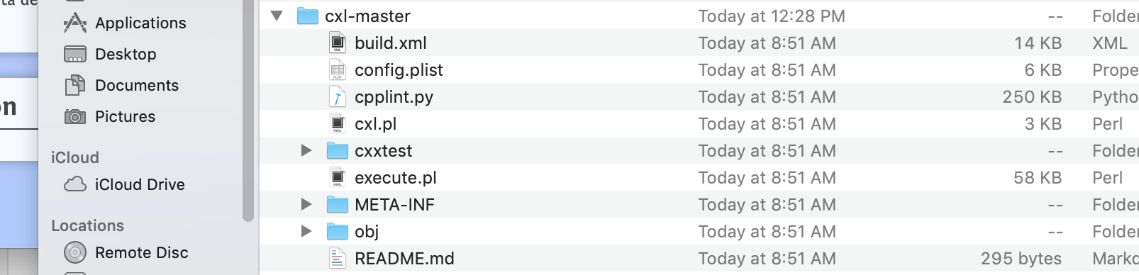

The reason is that the “config.plist” will not be found if the folder structure changes. After the plugin is uploaded you will set the specific assignment options, which is usually the test case that is used there. Then you can attach the plugin to the assignment through the drop-down menu and run it.

After running the program, the output will be similar to what is pictured below. The picture shows the normal output of Web-CAT, and the additional “Checking your Style” section. This is from the cxl plugin and displays the filename and line of where the style error is. It also gives a comment of how the user can fix the error. Along with a style score on a scale 0-100%. 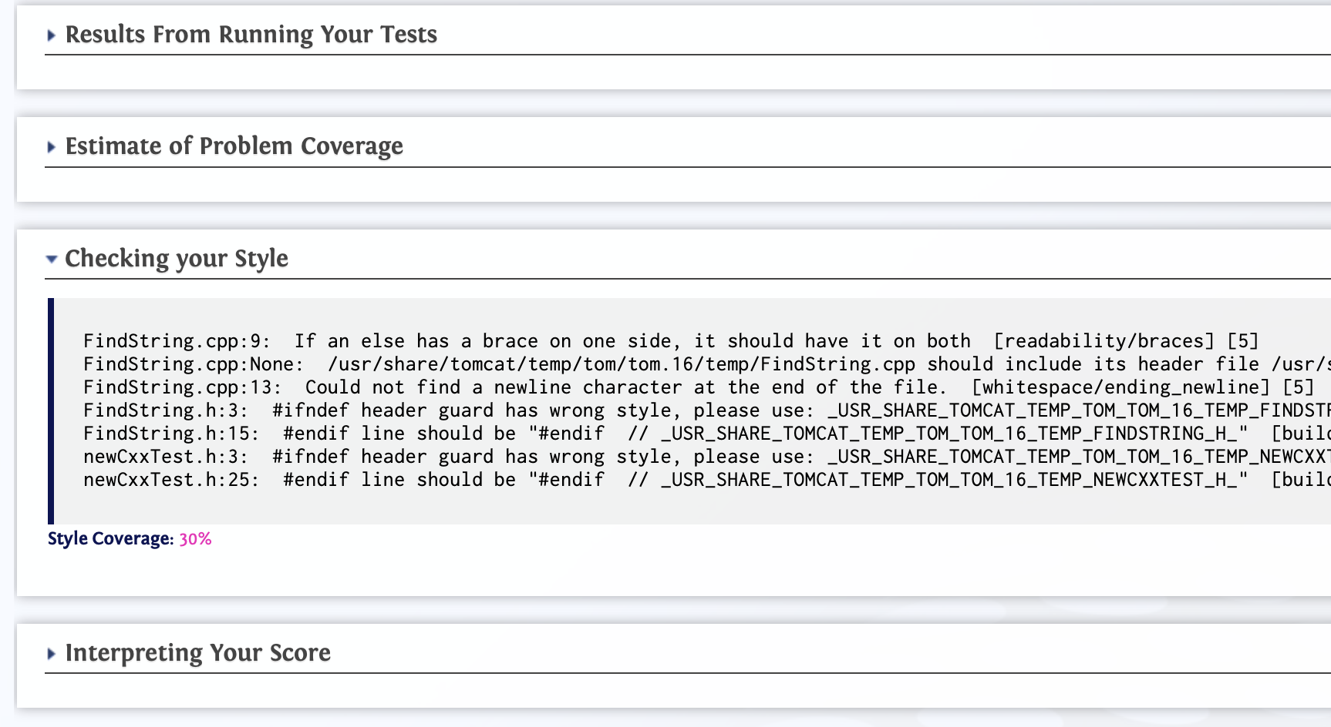

**RESULTS**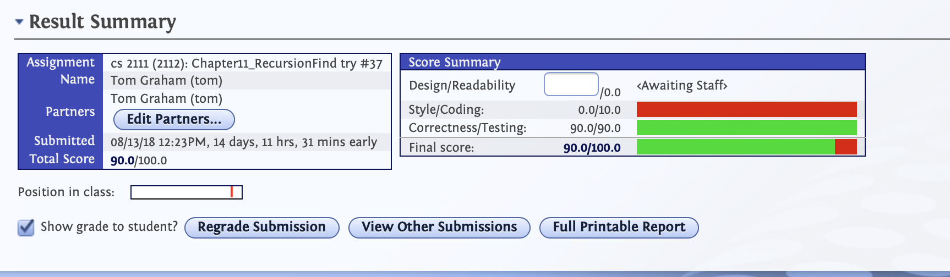

As seen above the previous results could not grade the style of the C++ code.

However, the results with the cxl plugin are much different (pictured below). This plugin enhances the previous CppTddPlugin by providing Style Checking by Google, meaning you do not need to run both plugins. The plugin connects all the different parts of the project together to provide output for the user via Web-CAT. This code was tested with different problems from various sources giving the best test results. The code was successful in these tests. Pictured below is the output after using the cxl plugin.

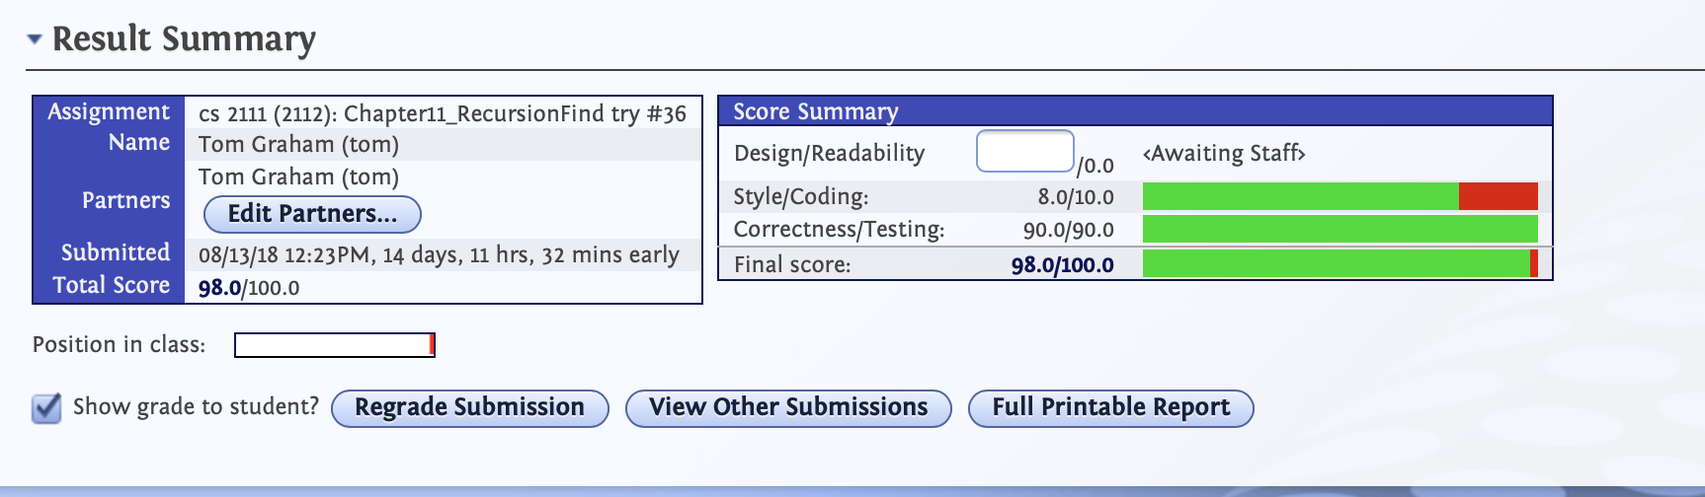

**CONCLUSION**

The cxl plugin will run the unit tests, provide testing results, and check the students code against a C++ Style standard provided by Google. This is a valid solution to the problem presented.

**REFERENCES**

Cpplint - https://github.com/google/styleguide/tree/gh-pages/cpplint

GoogleStyleGuide - http://google.github.io/styleguide/cppguide.html

Cxl - <https://github.com/simplesymmetry/cxl>

CxxTest – https://cxxtest.com/

WebCAT - <http://web-cat.org>

After the installation, go to /usr/share/Web-CAT/UserScripts/QCC/admin/cxl-master_zip and make cxl.pl and execute.pl executable

Chmod u+x cxl.pl

Chmod u+x execute.pl